

Eidoo — May Earned Media Article #1

27 May 2021

Prepared by AmaZix

Why You Want the Best Fiat on and off-Ramp



Source:  
<https://www.ripleys.com/weird-news/floating-ramp/>  
<https://www.ripleys.com/wp-content/uploads/2014/05/Floating-Skateboard-Ramp-Lake-Tahoe-Dream-Big-California-Bob-Burnquist-6.jpg>

I remember it was a Wednesday. A clear day with some cloud cover, neither hot nor cold. The kids were starting to come out to the school playground visible from my window while sitting at the computer. A cat settled on my lap. The neighbor on the third floor was yelling at her husband in a language I didn't know as a typical ex-pat. Something about her cat. Everything seemed normal. Calm. I, however, was uneasy. I had just sent my first bitcoin transaction. Previously I had to send my small savings to an offshore account on a centralized exchange that took days. I called my neighbors’ cat *fiat on-ramp* since that day.

First times are difficult. Every little success seems like a triumph, but they are always accompanied by mistakes that you learn from experience. That is, the polite way of saying "screwing up".

This is also the case with crypto investing. The first time you try it is somewhat stepping out of your financial comfort zone. A good variety of fiat on/off-ramps is the best antidote to help you climb the crypto learning curve.

It is not only a problem to invest fiat, but also to get it back or use your profits. Suddenly your money loses the physical presence in the world of human beings and if you want to see it back in your pocket to regain confidence in those overly decorated pieces of paper it could take several days.

If one thinks about it, it is to a certain extent incredible that the crypto sector has not been ignored if we take into account how difficult it was to invest in the beginning. The situation with fiat on/off-ramp has improved a lot, thanks to the advancement in the methods of interaction with the fiat world.

This drawback is possibly the most compelling reason for many cryptocurrency investors to minimize interactions between their crypto wallet and their fiat life.

There is however another important consideration that we sometimes fail to see or want to overlook particularly relevant for fiat on/off-ramp cases. In general, we like to have our money in cryptos because it is an investment but also because it is right there that our money is more ours. Nobody touches, our money in our crypto wallet, provided, of course, that the wallet is non-custodial. Otherwise, moving from a traditional banking account to a wallet where your keys are not really yours is a decision that does not find much justification.

With this last point, quite important, the options available to us are reduced quite a bit.

# Fiat on-Ramp

The most obvious option, which was available from the beginning, is the traditional bank transfer. This method always involves a KYC/AML process, and if it does not, beware of that exchange.

New options have been added that streamline the process and give you more flexibility. On the one hand, you have peer-to-peer exchanges, the transfer process is similar, but you don't need to send your money to any other intermediary. It is just your account and the account of the person you are trading with. [Bisq](https://bisq.network/) is an example of this rather uncommon method. The fiat ramp-on/off experience in this type depends on the users’ bank’s speeds.

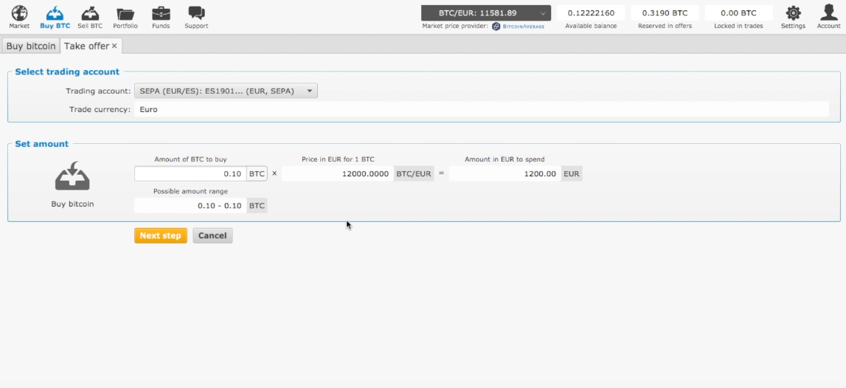

Source: <https://www.youtube.com/watch?v=-o9CKiivyIc&t=2m21s>

Cards have also been there as an alternative to incorporate crypto investments. This way one buys crypto directly with their fiat card.

Finally, a related method to the traditional transfer is the instant transfer, like Instant SEPA, which is becoming very popular and reduces waiting times to a few seconds. Coinbase, eToro, and [Eidoo](https://eidoo.io/) are examples of crypto companies supporting instant transfers if your bank also does.

# Fiat off-Ramp

In this department, the options have always been more limited. Bank transfers were always the most popular option here from the beginning, somewhat limited by the inflexibility of traditional banking though. In fact, if you did not receive a notice from your bank warning you about the risks of demonic crypto investments when detecting a wire transfer from an exchange, you may consider yourself lucky.

As in the case of fiat on-ramp options, in addition to bank transfers, there is the possibility to make instant transfers towards various providers.

The integration of payments with Instant SEPA has greatly eased the initial barrier to interact in the crypto ecosystem. The problem with this type of payment is that it requires that both your bank and the entity that supports your DeFi wallet must enable this type of transaction. This is an important point to take into account when choosing the right wallet for your needs.

Finally, an option that has become popular over time has been the use of debit crypto cards with crypto funds.

With this type of card one can access their funds in ETH or stablecoins making it the best DeFi-fiat off-ramp solution. There is no need to worry about which side of the blockchain you are on at any given moment. But above all, one does not have to foresee how much money one is going to need in crypto or fiat. You can simply use the card the moment you need to liquidate part of your cryptos. This option is particularly interesting to liquidate only crypto assets as you need them in a way that minimally compromises your portfolio. Eidoo is a popular case with [such a card](https://site.moneyfold.co.uk/eidoo-card).

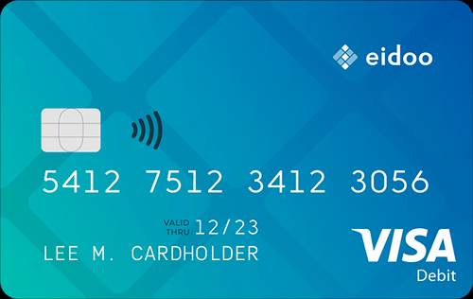

Source: <https://site.moneyfold.co.uk/eidoo-card>

Modern DeFi wallets and exchanges offer multiple fiat on/off-ramp options to make your cryptos an asset in every way both in your digital life and in your life on the other side of the Matrix. In essence, making new finance like what you already know but with cryptos.